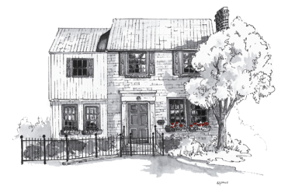
The Family Academy of Bethesda

4324 Montgomery Ave., Bethesda, MD 20814 Tel: 301-656-5437 Fax: 301-656-2209
Email: www.familyacademyofbethesda@gmail.com
Web: www.familyacademyofbethesda.com

PERMISSION TO WALK

I give The Family Academy of Bethesda permission to take my child
___________________________(child’s name)to Family Academy’s
playgrounds located at 4324 Montgomery Avenue and 4310 Montgomery Avenue. It might be necessary for us to use the sidewalk along the street to walk to and from the playground.

This form will be kept on file and will remain valid for the duration of
my child’s enrollment at The Family Academy of Bethesda.

______________________ _______________
Parent’s Signature Date

______________________
Parent’s Printed Name

